**A Data Availability Statement**

Psychological Contract

H6

H5

Non-Standard Service

Performance

H1

H4

H2

H3

Sharing Knowledge

**Figure. The research framework**

Source: Developed in this research (2023)

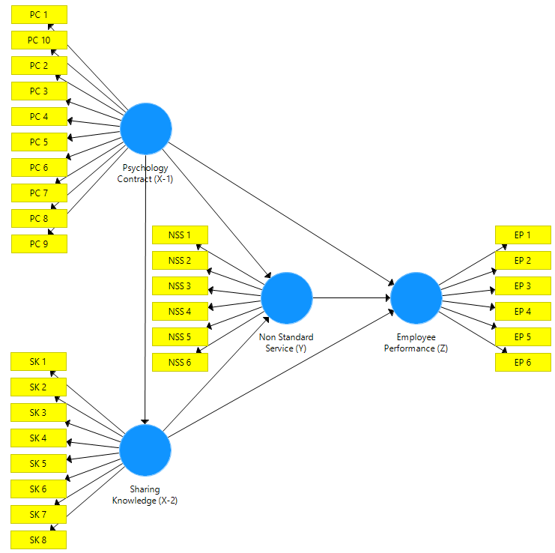

Figure: Structural Initial Design Model

Source: SmartPLS.3 Processing Result Data, 2023

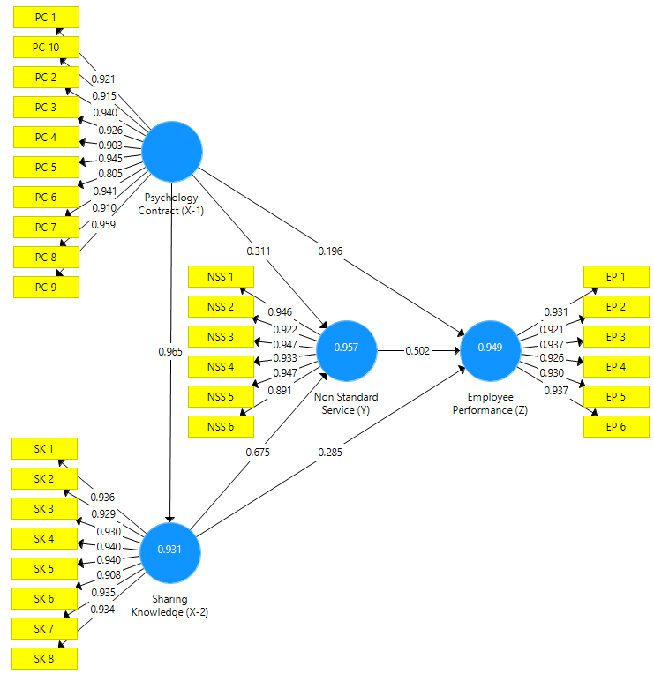

Figure: Run PLS Algorithm

Source: SmartPLS.3 Processing Result Data, 2023

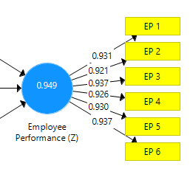

Source: SmartPLS.3 Processing Result Data, 2023

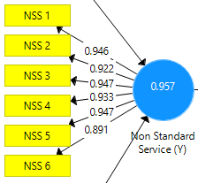

Source: SmartPLS.3 Processing Result Data, 2023

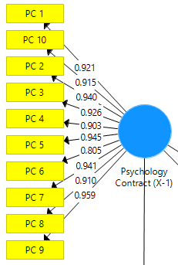

Source: SmartPLS.3 Processing Result Data, 2023

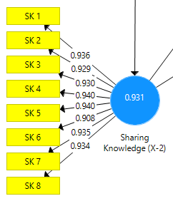

Source: SmartPLS.3 Processing Result Data, 2023

***Outer Loading***

|  |  |  |  |  |
| --- | --- | --- | --- | --- |
| **Konstruk** | **Psychology Contract** | **Knowledge Sharing** | **Non Standard Service** | **Employee Performance** |
| EP 1 |  |  |  | 0,931 |
| EP 2 |  |  |  | 0,921 |
| EP 3 |  |  |  | 0,937 |
| EP 4 |  |  |  | 0,926 |
| EP 5 |  |  |  | 0,930 |
| EP 6 |  |  |  | 0,937 |
| NSS 1 |  |  | 0,946 |  |
| NSS 2 |  |  | 0,922 |  |
| NSS 3 |  |  | 0,947 |  |
| NSS 4 |  |  | 0,933 |  |
| NSS 5 |  |  | 0,947 |  |
| NSS 6 |  |  | 0,891 |  |
| SK 1 |  | 0,936 |  |  |
| SK 2 |  | 0,929 |  |  |
| SK 3 |  | 0,930 |  |  |
| SK 4 |  | 0,940 |  |  |
| SK 5 |  | 0,940 |  |  |
| SK 6 |  | 0,908 |  |  |
| SK 7 |  | 0,935 |  |  |
| SK 8 |  | 0,934 |  |  |
| PC 1 | 0,921 |  |  |  |
| PC 2 | 0,940 |  |  |  |
| PC 3 | 0,926 |  |  |  |
| PC 4 | 0,903 |  |  |  |
| PC 5 | 0,945 |  |  |  |
| PC 6 | 0,805 |  |  |  |
| PC 7 | 0,941 |  |  |  |
| PC 8 | 0,910 |  |  |  |
| PC 9 | 0,959 |  |  |  |
| PC 10 | 0,915 |  |  |  |

Source: SmartPLS.3 Processing Result Data, 2023

***Cross Loading* Employee Performance**

| **Konstruk** | **Employee Performance** |
| --- | --- |
| EP 1 | 0,931 |
| EP 2 | 0,921 |
| EP 3 | 0,937 |
| EP 4 | 0,926 |
| EP 5 | 0,930 |
| EP 6 | 0,937 |

Sumber : Sumber : Diolah SmartPLS 3 2023

**Nilai *Cross Loading* Non Standard Service**

| **Konstruk** | **Non Standard Service** |
| --- | --- |
| NSS 1 | 0,946 |
| NSS 2 | 0,922 |
| NSS 3 | 0,947 |
| NSS 4 | 0,933 |
| NSS 5 | 0,947 |
| NSS 6 | 0,891 |

Source: SmartPLS.3 Processing Result Data, 2023

***Cross Loading* Knowledge Sharing**

| **Konstruk** | **Knowledge Sharing** |
| --- | --- |
| SK 1 | 0,936 |
| SK 2 | 0,929 |
| SK 3 | 0,930 |
| SK 4 | 0,940 |
| SK 5 | 0,940 |
| SK 6 | 0,908 |
| SK 7 | 0,935 |
| SK 8 | 0,934 |

Source: SmartPLS.3 Processing Result Data, 2023

**Nilai *Cross Loading* Psychology Contract**

| **Konstruk** | **Psychology Contract** |
| --- | --- |
| PC 1 | 0,921 |
| PC 2 | 0,940 |
| PC 3 | 0,926 |
| PC 4 | 0,903 |
| PC 5 | 0,945 |
| PC 6 | 0,805 |
| PC 7 | 0,941 |
| PC 8 | 0,910 |
| PC 9 | 0,959 |

Source: SmartPLS.3 Processing Result Data, 2023

**AVE dan Latent Variable Correlation**

|  | **AVE** | **Psychology Contract** | **Knowledge** Sharing | **Non Standard Service** | **Employee Performance** |
| --- | --- | --- | --- | --- | --- |
| Employee Performance (Z) | 0,865 | 0,955 | 0,964 | 0,969 | 1,000 |
| Non Standard Service (Y) | 0,867 | 0,962 | 0,975 | 1,000 | 0,969 |
| Psychology Contract (X-1) | 0,841 | 1,000 | 0,965 | 0,962 | 0,955 |
| Knowledge Sharing (X-2) | 0,868 | 0,965 | 1,000 | 0,975 | 0,964 |

Source: SmartPLS.3 Processing Result Data, 2023

***Composite Reliability***

|  |  |
| --- | --- |
| **Variabel** | ***Composite Reliability*** |
| Employee Performance (Z) | 0,975 |
| Non Standard Service (Y) | 0,975 |
| Psychology Contract (X-1) | 0,981 |
| Sharing Knowledge (X-2) | 0,981 |

Source: SmartPLS.3 Processing Result Data, 2023

***Cronbach’s Alpha***

|  |  |
| --- | --- |
| **Variabel** | **Cronbach’s Alpha** |
| Employee Performance (Z) | 0,969 |
| Non Standard Service (Y) | 0,969 |
| Psychology Contract (X-1) | 0,979 |
| Sharing Knowledge (X-2) | 0,978 |

Source: SmartPLS.3 Processing Result Data, 2023

***R-square***

|  |  |  |
| --- | --- | --- |
|  | **R Square** | **R Square Adjusted** |
| Employee Performance | 0,949 | 0,948 |
| Non Standard Service | 0,957 | 0,957 |
| Sharing Knowledge | 0,931 | 0,931 |

Source: SmartPLS.3 Processing Result Data, 2023

***Effect Size***

|  |  |  |  |
| --- | --- | --- | --- |
|  | **Berbagi Pengetahuan** | **Pelayanan Tidak Standar** | **Kinerja Karyawan** |
| Psychology Contract | 0,965 | 0,962 | 0,955 |
| Sharing Knowledge |  | 0,675 | 0,624 |
| Non Standard Service |  |  | 0,502 |

Source: SmartPLS.3 Processing Result Data, 2023

***Bootstrapping Inner Model***

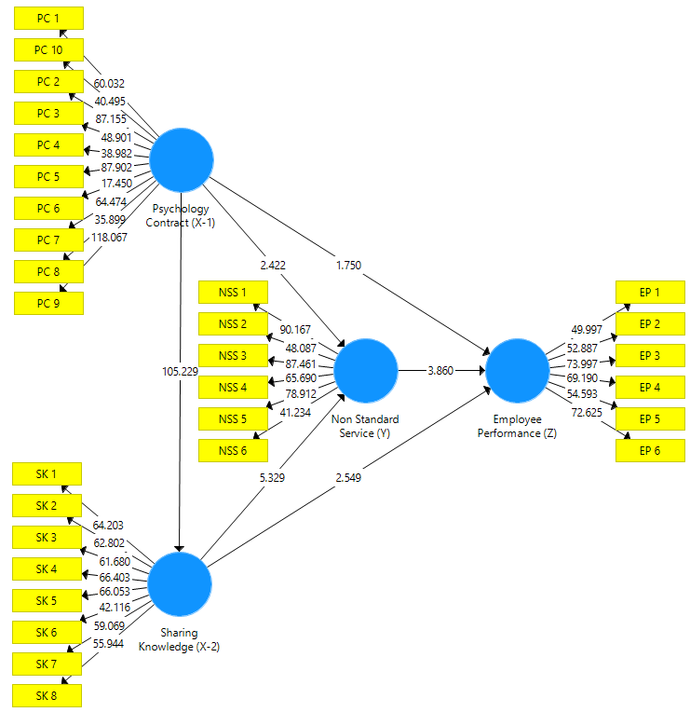

Source: SmartPLS.3 Processing Result Data, 2023

***Path Coefficiant***

|  | Original Sample (O) | Sample Mean (M) | Standard Deviation (STDEV) | T Statistics (|O/STDEV|) | P-Values | Keterangan |
| --- | --- | --- | --- | --- | --- | --- |
| Psychology Contract (X-1) -> Sharing Knowledge (X-2) | 0,965 | 0,965 | 0,009 | 105,229 | 0,000 | Signifikan |
| Sharing Knowledge (X-2) -> Non Standard Service (Y) | 0,675 | 0,650 | 0,127 | 5,329 | 0,000 | Signifikan |
| Sharing Knowledge (X-2) -> Employee Performance (Z) | 0,285 | 0,304 | 0,112 | 2,549 | 0,006 | Signifikan |
| Non Standard Service (Y) -> Employee Performance (Z) | 0,502 | 0,504 | 0,130 | 3,860 | 0,000 | Signifikan |
| Psychology Contract (X-1) -> Non Standard Service (Y) | 0,311 | 0,336 | 0,128 | 2,422 | 0,008 | Signifikan |
| Psychology Contract (X-1) -> Employee Performance (Z) | 0,196 | 0,175 | 0,112 | 1,750 | 0,040 | Signifikan |

Source: SmartPLS.3 Processing Result Data, 2023

**Total *Effect***

|  | **Original Sample (O)** | **Sample Mean (M)** | **Standard Deviation (STDEV)** | **T Statistics (|O/STDEV|)** | **P Values** |
| --- | --- | --- | --- | --- | --- |
| Non Standard Service -> Employee Performan | 0,502 | 0,504 | 0,130 | 3,860 | **0,000** |
| **Psychology Contrac -> Employee Performan** | **0,955** | **0,955** | **0,010** | **93,808** | **0,000** |
| Psychology Contra -> Non Standard Service | 0,962 | 0,963 | 0,011 | 89,051 | **0,000** |
| Psychology Contract -> Sharing Knowledge | 0,965 | 0,965 | 0,009 | 105,229 | **0,000** |
| **Sharing Knowledge -> Employee Performance** | **0,624** | **0,627** | **0,093** | **6,734** | **0,000** |
| Sharing Knowledge -> Non Standard Service | 0,675 | 0,650 | 0,127 | 5,329 | **0,000** |

Source: SmartPLS.3 Processing Result Data, 2023